SUPERVISION
Date / time: 23/10/2025

Main issues discussed
- Overall evaluation of the proposal and its main issues
- What a literature review should cover and how it should be written
- Clearly explain the three models (their principles, the reasons for choosing them, and how they relate to the task).

Work shown
The performance of kNN, Random Forest, and InceptionTime on the LARa dataset.
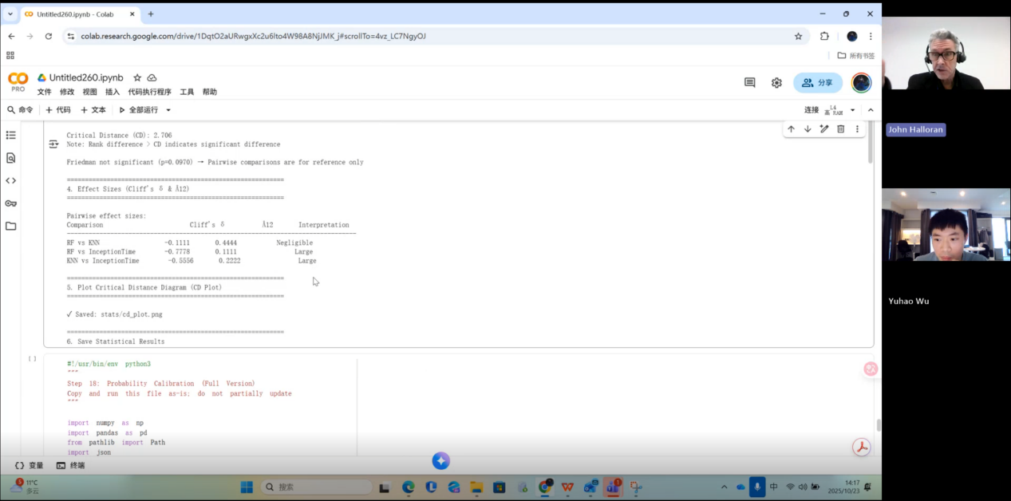

Questions asked; how questions were answered
- Do I also need to write the proposal in a way that is friendly and easy to understand for non-experts?

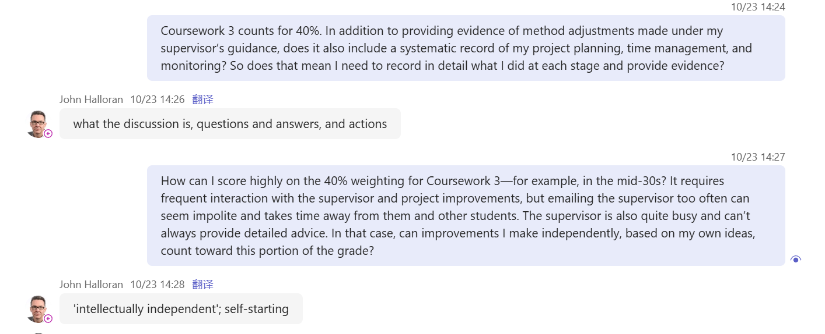
Answer
- Yes, and he recommended a machine learning book.
- What you should do is summarise what we discussed and why we discussed it. This includes which questions I asked you and how you answered them, and which questions you asked me and how I answered them—write all of this down.
- Supervision is only one part of the work. You need to engage actively with the supervision, but you also have to demonstrate your own academic independence.

Actions for next week
Provide an in-depth, technically detailed explanation of how kNN, Random Forest, and InceptionTime work.

Email
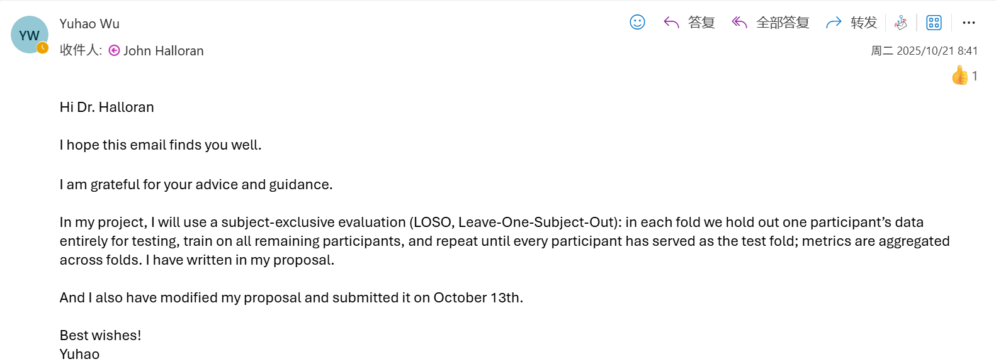

Computing Project
WORK DONE
1. The preprocessing of the LARa dataset, and the training and testing of 6 models (knn, random forest, inceptiontime, tst, minirocket, multirocket) on two datasets.
2. Preparing for the work of designing a new model.

Issues and challenges
- MultiRocket trains slowly on the RealWorld dataset.
- For the LARa dataset preprocessing, I have to manually enter the fold each time, which is very inconvenient.

Actions for next week
Use MiniRocket, MultiRocket, and TST to complete training and testing on all folds of the LARa dataset, summarise the results, and report them to my supervisor.
Read the machine learning book recommended by my supervisor.

Evidence
https://livecoventryac-my.sharepoint.com/:v:/g/personal/wuy176_uni_coventry_ac_uk/IQBMGpJdAegtR6ez_7kyIOrrAa9XlIXekBbaoNtcXco_3H8?e=Y2VWrD&nav=eyJyZWZlcnJhbEluZm8iOnsicmVmZXJyYWxBcHAiOiJTdHJlYW1XZWJBcHAiLCJyZWZlcnJhbFZpZXciOiJTaGFyZURpYWxvZy1MaW5rIiwicmVmZXJyYWxBcHBQbGF0Zm9ybSI6IldlYiIsInJlZmVycmFsTW9kZSI6InZpZXcifX0%3D

